

USER GUIDE

**WATCH HUB**

**ACCP 2.0 (Batch: NK_2202G1)**

*Project Instructor*

**Sir Muzammil Imam**

Submitted by:

|  |  |
| --- | --- |
| Student1359157 | ABDULLAH |
| Student1350284 | MUHAMMAD KAMIL KHAN |
| Student1357930 | MUHAMMAD FAIQ HAIDER |
| Student1355397 | ADEEN AHMED KHAN |
| Student1358134 | MUHAMMAD FAHAD NAEEM |
| Student1356962 | ATEEB |
| Student1356974 | MUHAMMAD HAMZA SHAHI |

**Snap Shots of website:**

**Splash Screen.**



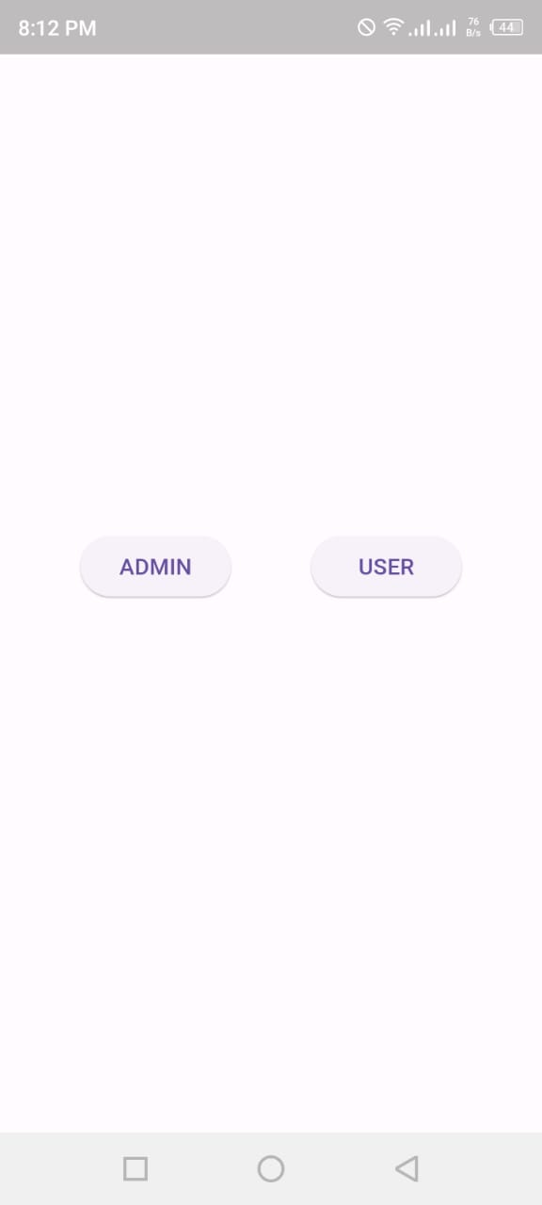

**Login Page.**

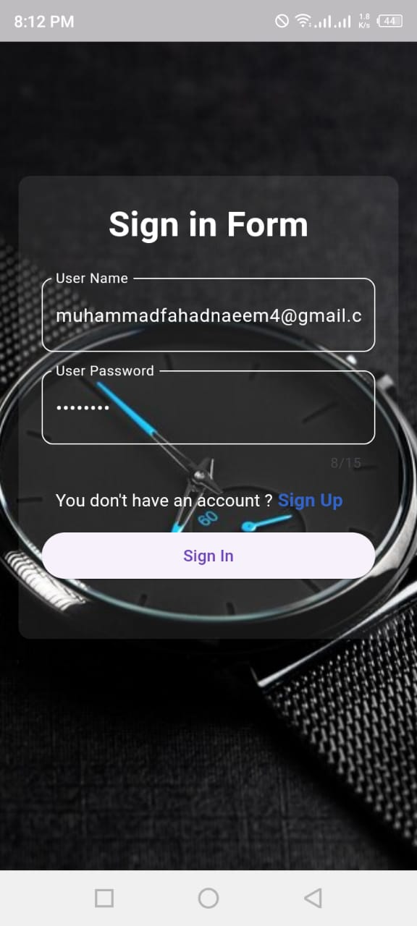

**Sign Up Page**

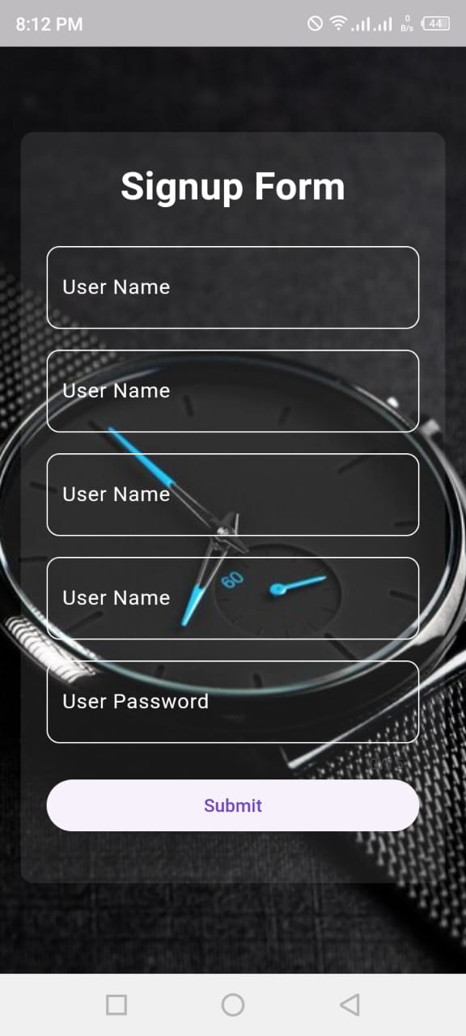

**Home Page.**

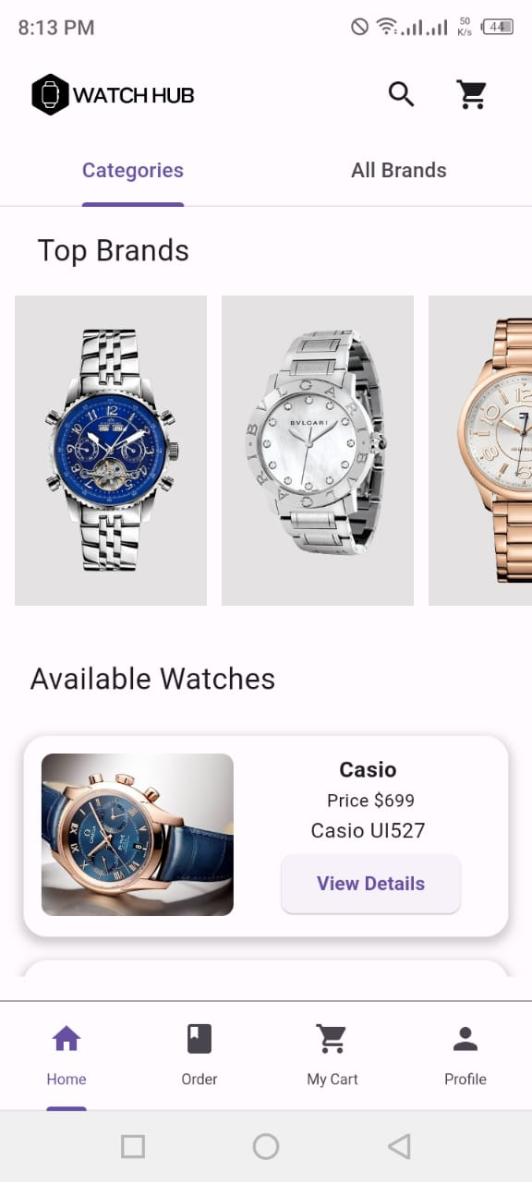

**Categories Page.**

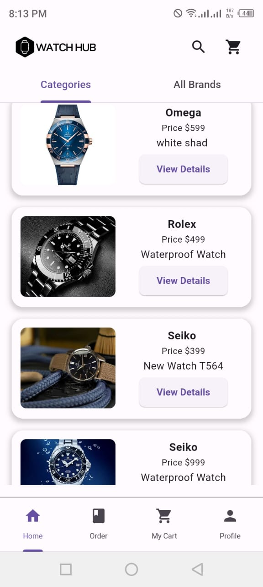

**All Brand Page.**

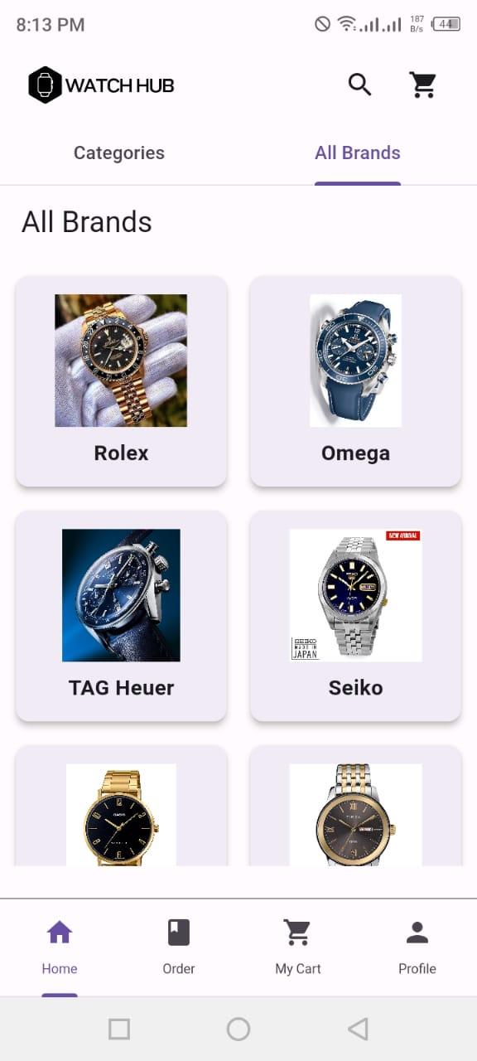

**Order Page.**

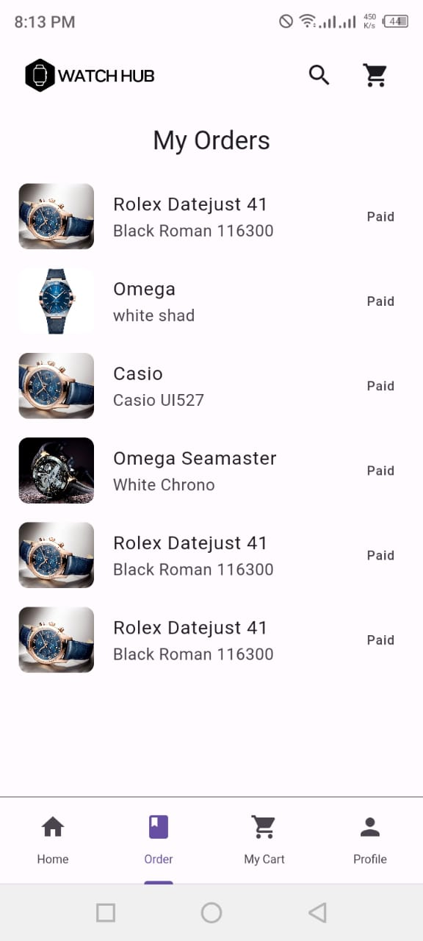

**Cart Page.**

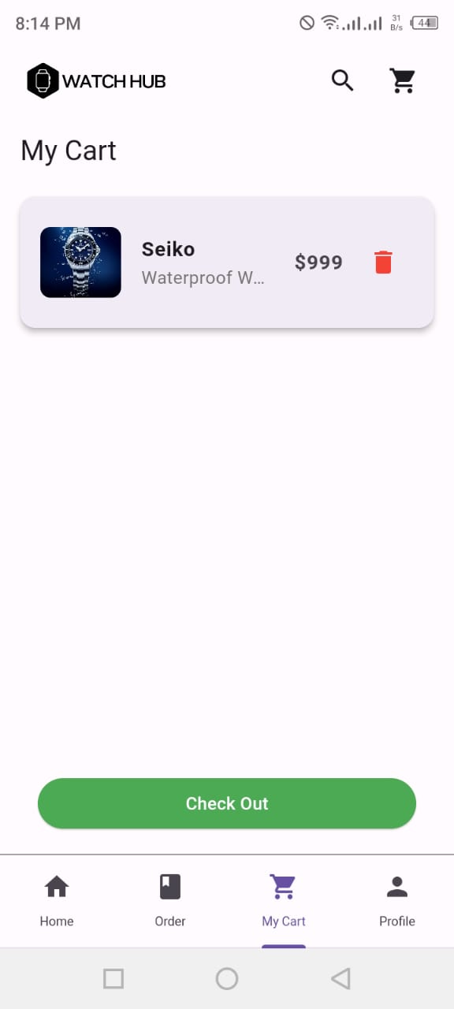

**Profile Edit Page.**

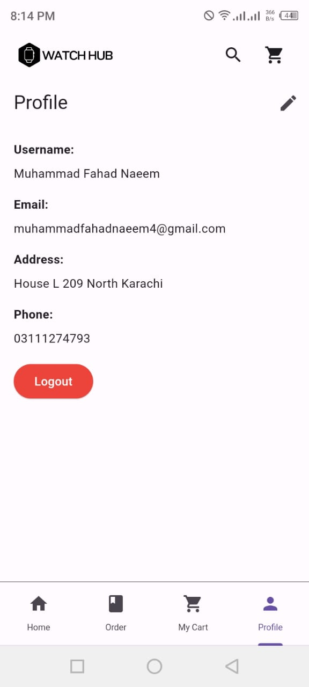

**Admin Product Add Page.**

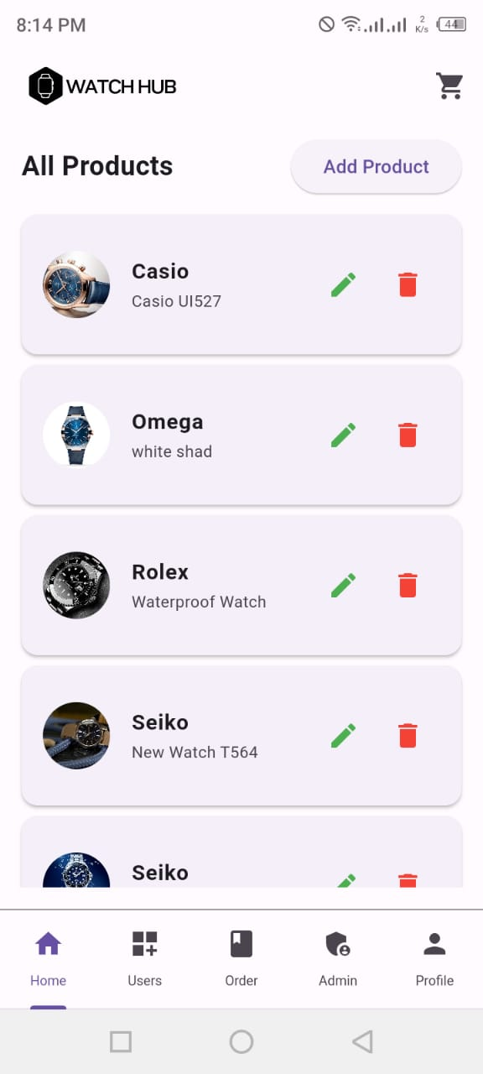

**Product Add Product Form.**

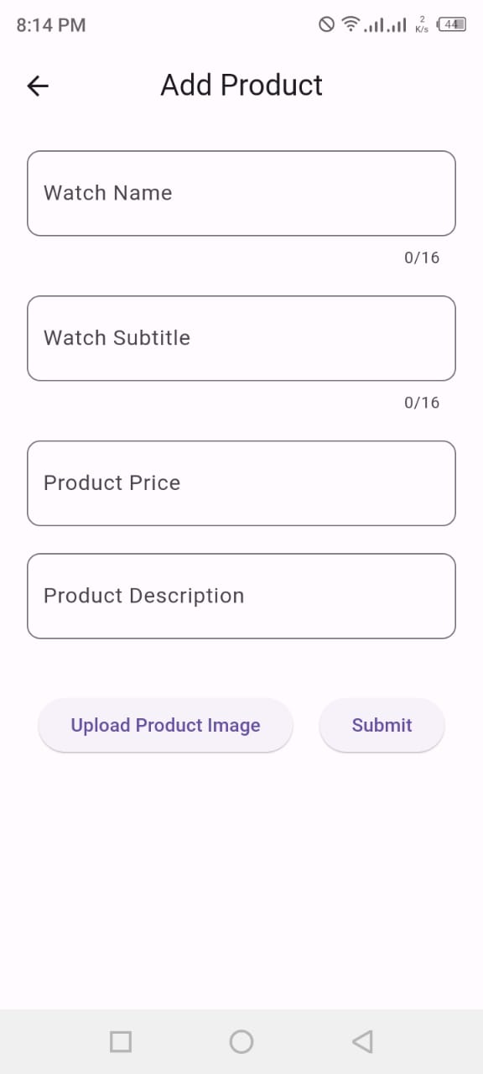

**User Detail Page For Admin.**

